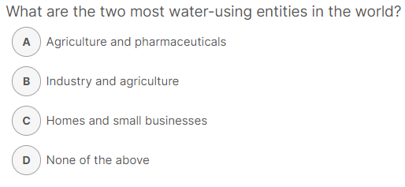TED ED – Video Questions

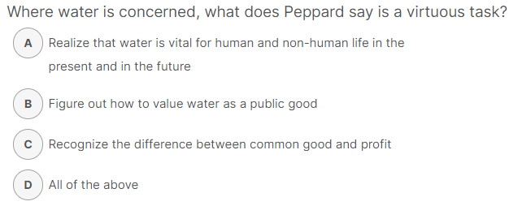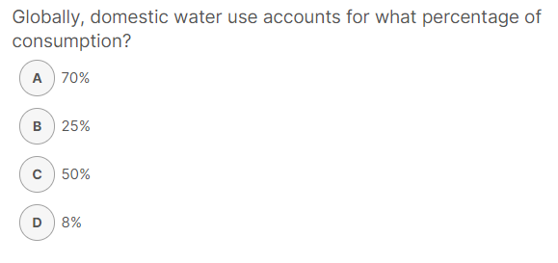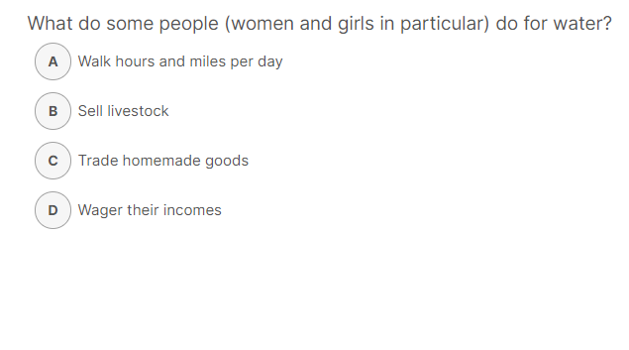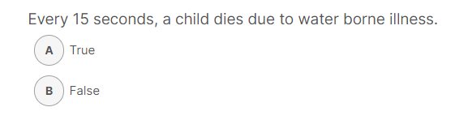

<https://ed.ted.com/lessons/fresh-water-scarcity-an-introduction-to-the-problem-christiana-z-peppard>